Governance

Governance on Azure is a set of rules, policies, and roles to define acceptable use of Azure resources.

Azure Policy: used to create policies in Azure.

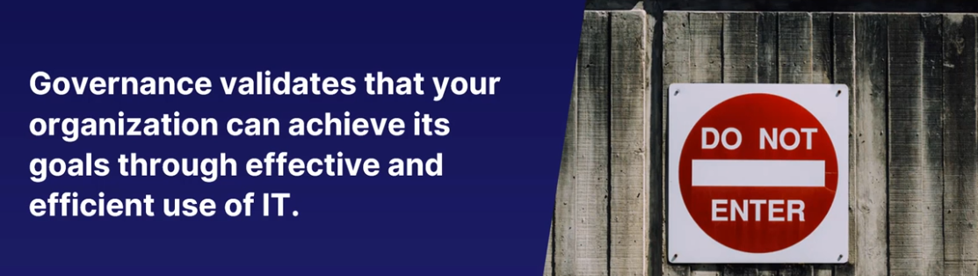

A policy is a set of rules. Rules to make sure that standards and agreements within your corporation are followed and that resources are compliant with these policies.

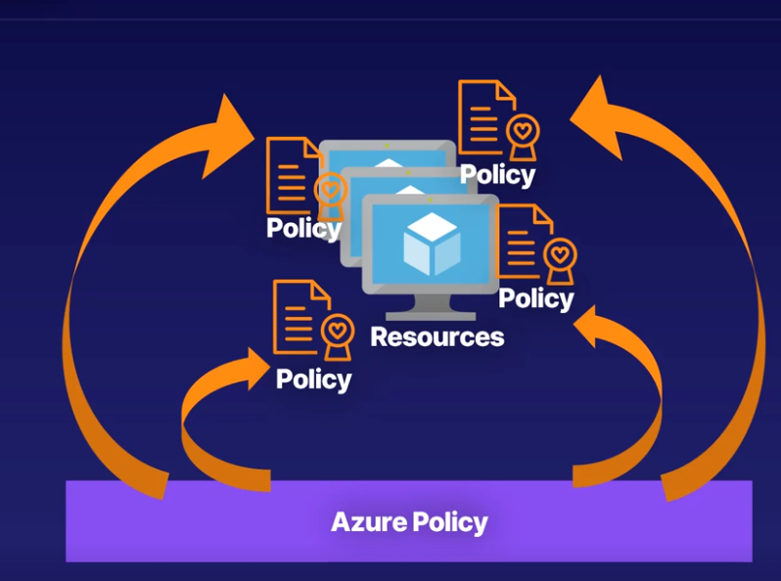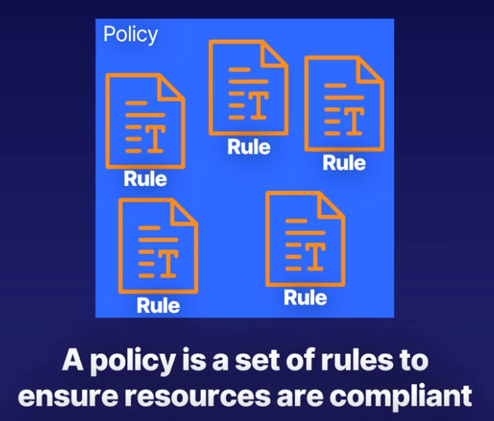

Role-based access control lets you define which users have access to specific Azure resources, what they can do with those resources, and what areas they have access to

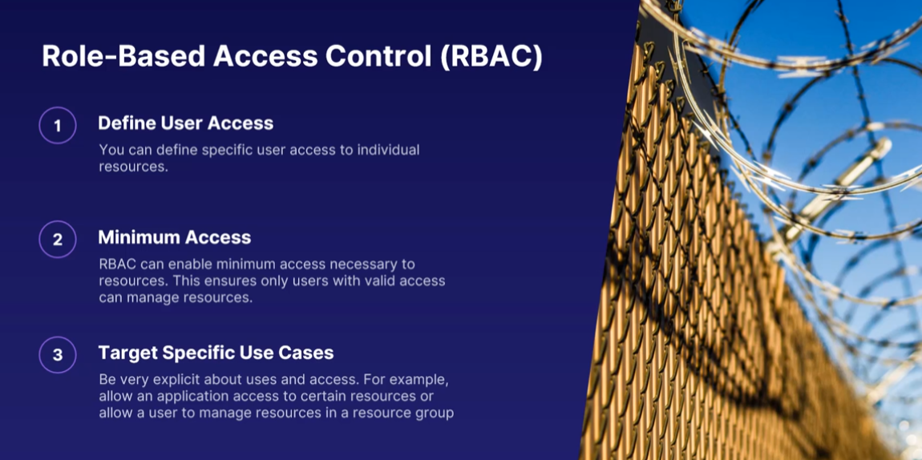

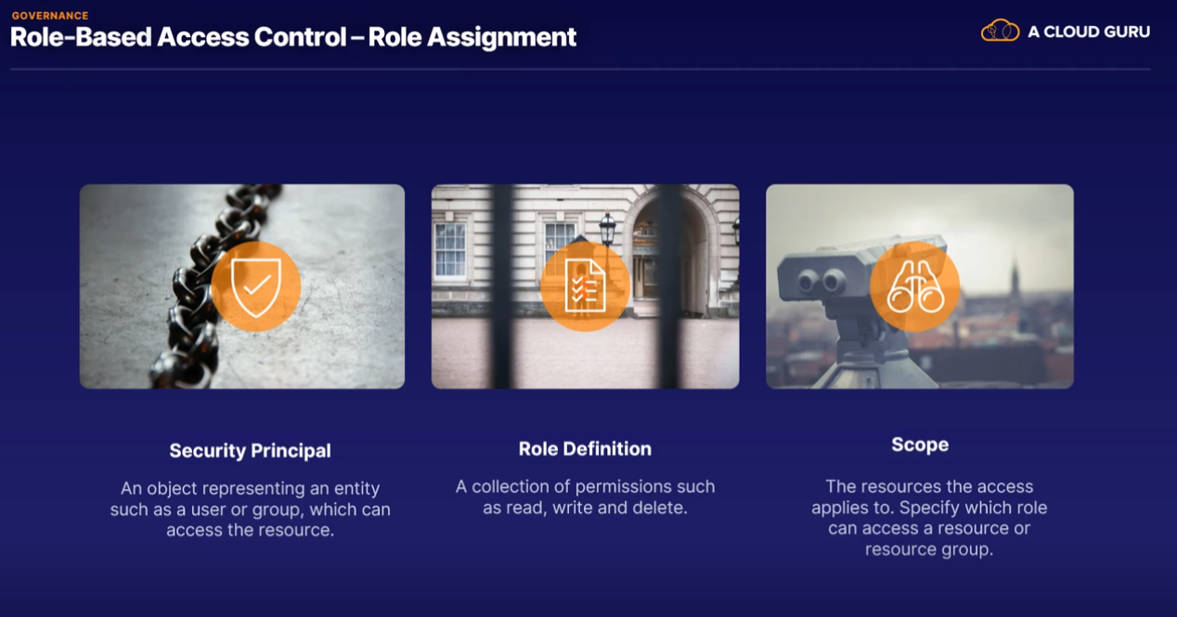

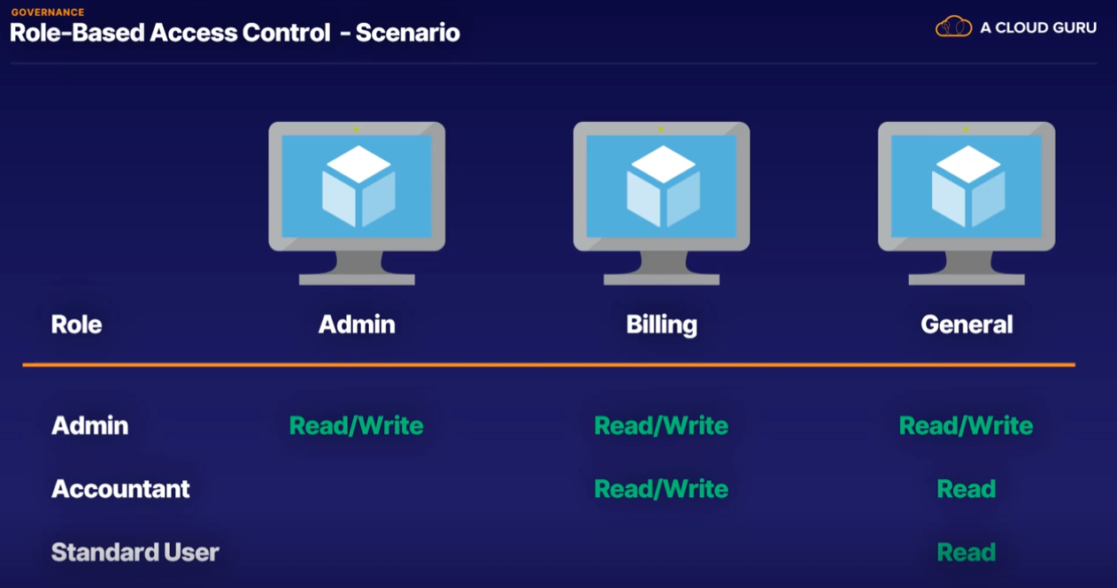

Locks: A simple and efficient tool to manage changes and removal of resources are locks.

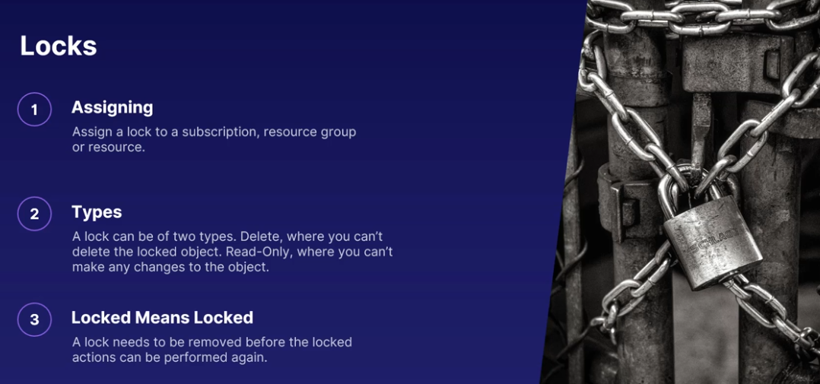

Blueprints are templates for creating Azure resources.

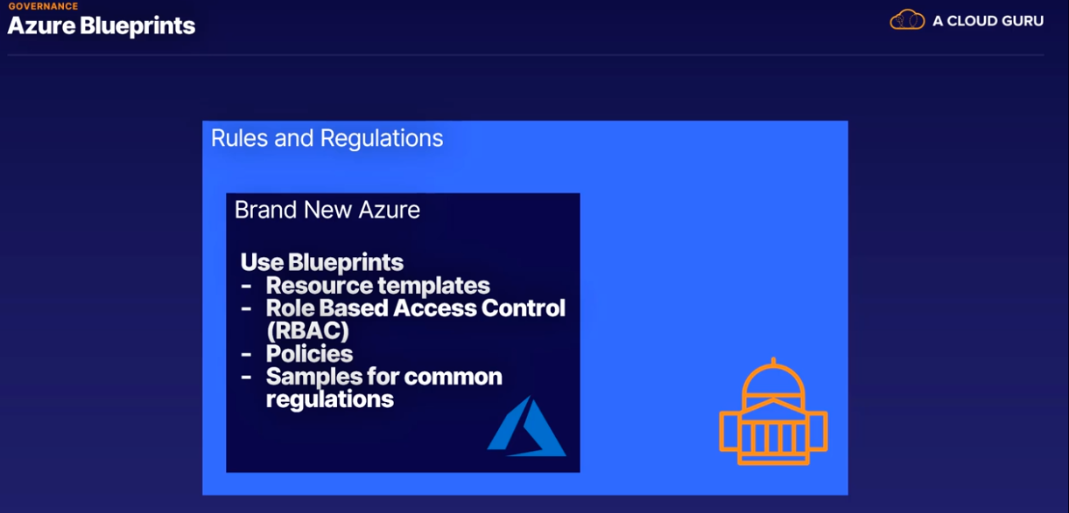

Azure Blueprints pack everything you need, including templates for which resources to create user permissions using RBAC and any necessary policies. All in one easy pill - I mean, package.

Cloud Adoption Framework: **This is collection of documents that takes you through every step of the journey towards the cloud.** You get guidance on how to define strategies for adoption, planning the move, what it means to be ready for the cloud, reasons for adopting the cloud, improving your governance and establishing practices around it, and managing a living, breathing cloud architecture.

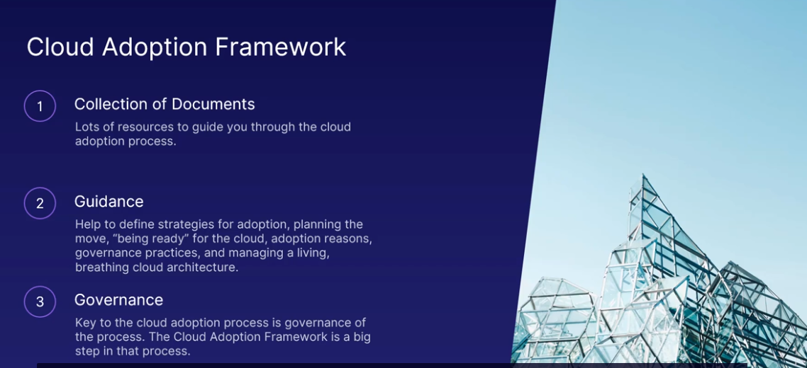

Azure Advisor for Security Assistance: While Azure Advisor is a separate blade and a separate portal within the Azure portal.

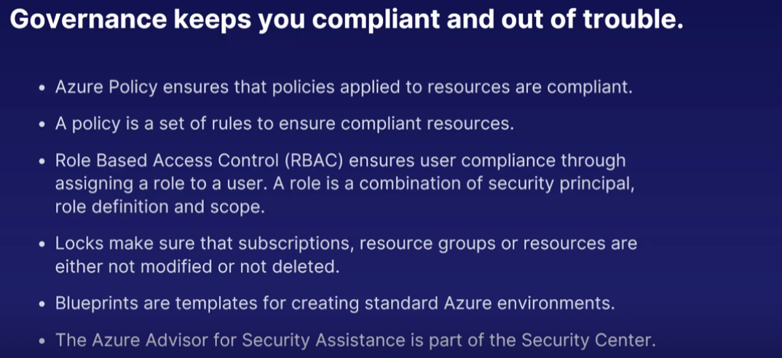

Azure Monitor

Telemetry is information about how services or devices are performing. This information is passed to a central point for further analysis. In azure the telemetry all goes into Azure Monitor which gives you this lovely dashboard in the Azure Portal.

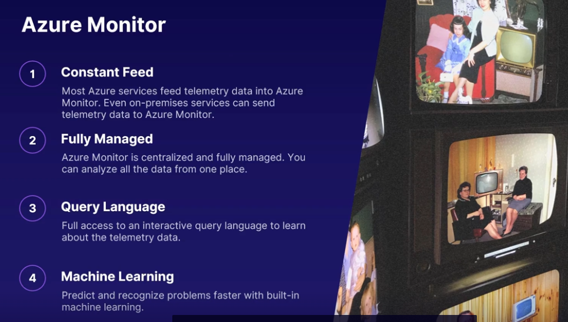

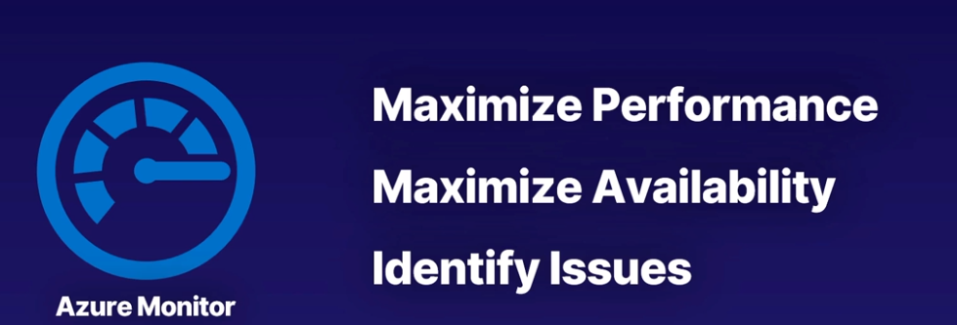

Monitoring Tools

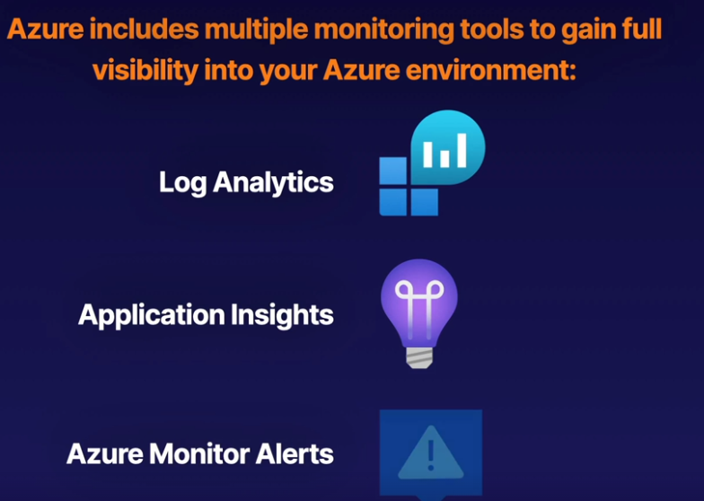

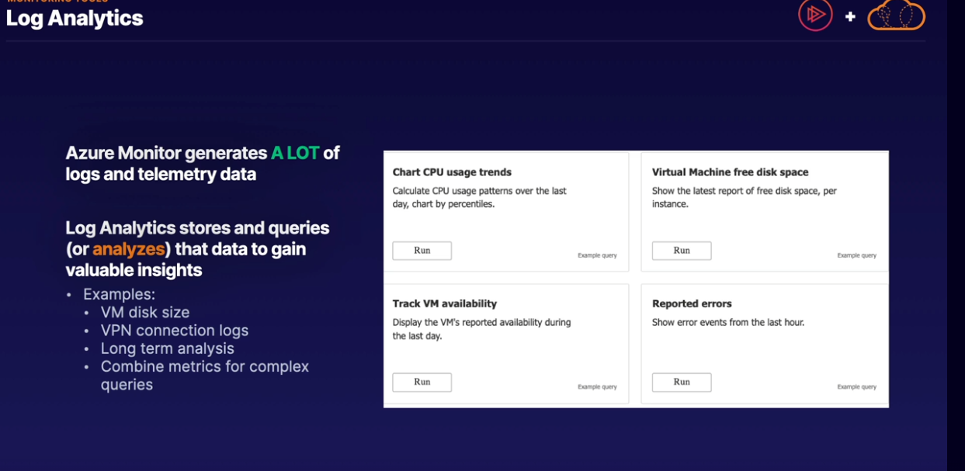

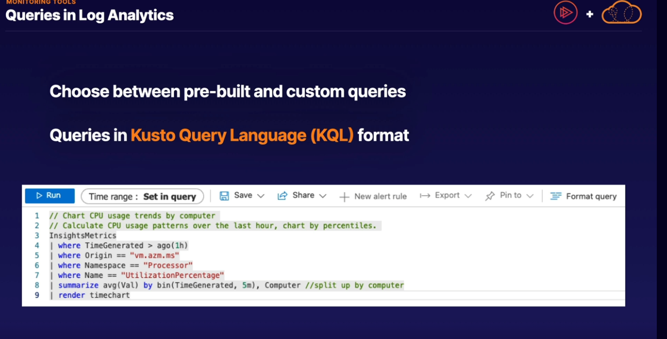

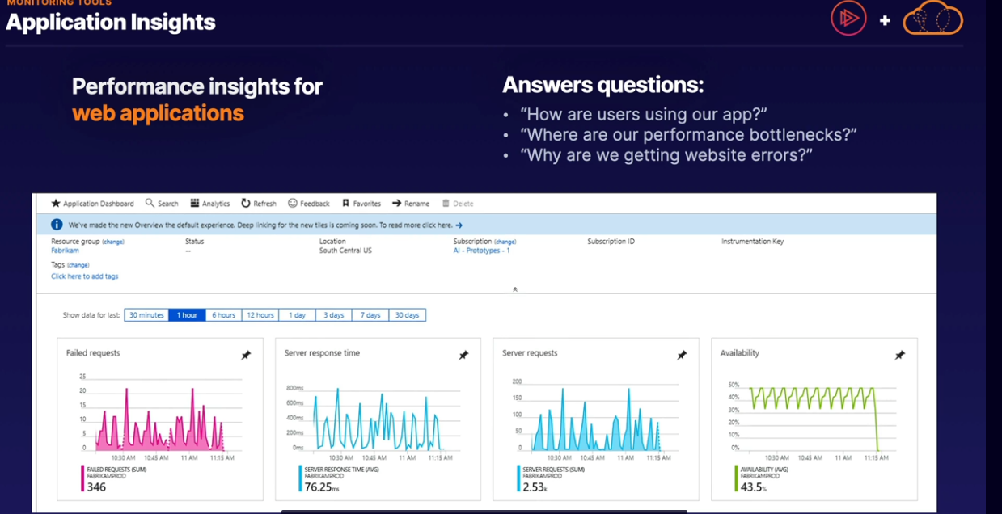

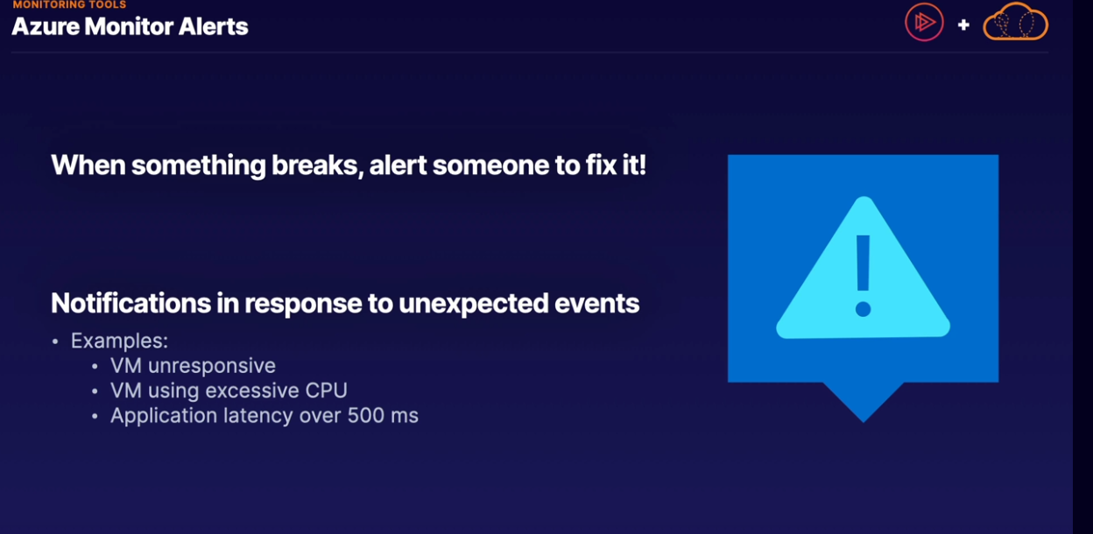

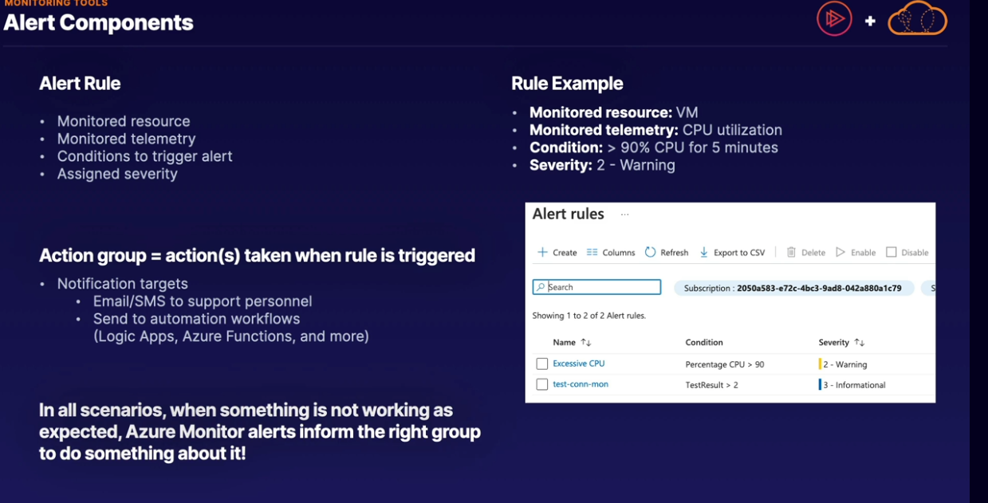

Maintenance

